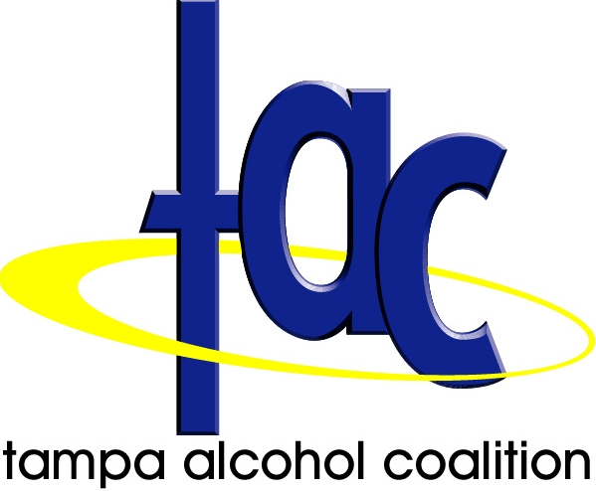

2012 Hillsborough County Alcohol Facts

2011 Hillsborough County Sheriff’s Office (HCSO) Central Breath Testing Data
- 4,463 DUI arrests countywide (15% decrease from 5,236 in 2010) with 239 arrests in 18 to 20 age group
- 2,188 Tampa Police Department DUI arrests (9% decrease from 2,392 in 2010)

2010 Traffic Crash Facts- Florida Department of Highway Safety and Motor Vehicles (DHSMV) Hillsborough County Data
- 54 Alcohol-related fatalities (13% decrease from 62 in 2009)
- 1,363 Alcohol-related crashes (4% decrease from 1,422 in 2009)
- 980 Alcohol-related injuries (5% decrease from 1,031 in 2009)
- Hillsborough County is #3 in the state for alcohol-related crashes, #3 in injuries; #2 in fatalities

2010 Florida Department of Law Enforcement UCR Statistics*
- 5,096 DUI arrests in Hillsborough County (highest # of DUI arrests in the state in 2010)
* FDLE UCR statistics differ from HCSO CBT data in the way that the DUI arrests are categorized
- 3,791 Liquor Law Violations in Hillsborough

2010 Underage Drinking Citations
- 632 Notices to Appear (State Attorney’s Office) -up from 614 in 2009

2010 Florida Youth Substance Abuse Survey (FYSAS) Hillsborough County Report
 | Lifetime Alcohol Use | Past 30-Day Alcohol Use | Binge Drinking  Rate | Drunk or High at School
High School | 69.1% | 41.2% | 22.4% | 19.6%
Middle School | 30.3% | 14.1% | 6.8% | 6.7%

2012 Core Survey of College Students- USF students under age 21: Past 30 day prevalence
- 55.2% drank alcohol
- 26.7% drove under the influence
- 5% had 6 or more binges in the past 2 weeks

2011 Hillsborough County Active Alcoholic Beverage Licenses- DABT
- 678 Beer, wine and liquor package or consumption on premise licenses
- 2,557 Total liquor licenses, all types

Underage/ Young Adult Driving Under the Influence (DUI) Facts:
18 to 20 year olds made up only 4.9% of licensed drivers in Hillsborough yet comprised 5.5% of DUI arrests, 7.8% of drinking drivers in crashes and 8.8% of fatal crashes in 2009 (HCSO, DHSMV). 18 to 27 year olds made up 18.3% of licensed drivers yet comprised 44.1% of the drinking drivers in fatal alcohol crashes in 2009 (DHSMV).

Florida Alcohol Laws- under age 21
In Florida, it is illegal for anyone under age 21 to drive with any alcohol in their system; a BAC of .02 or higher can lead to a 6 month driver’s license suspension (Zero Tolerance law). Driving with a BAC of .08 or under the influence of any amount of alcohol and/ or drugs may result in a DUI arrest. It is illegal for a person under the age of 21 to purchase or possess alcoholic beverages, and for anyone to purchase or provide alcohol for persons under the age of 21. Sale of alcoholic beverages to underage individuals is a second degree misdemeanor. Adults who allow underage drinking parties in their home can be arrested for violating the open house party statute. Teens or young adults under age 21 using false identification (fake ID) can be charged with a felony.

Cost of Underage Drinking in Hillsborough County per year (University of Miami Research published in 2009)
- $52,289,000- Cost of Motor Vehicle Crashes (highest in state)
- $205,100,000- Total Cost (includes crashes, injuries, suicide, drowning, violent crime)

Contact: Ellen Snelling at er.snelling@verizon.net 813-731-2696: www.tampatac.org Tampa Alcohol Coalition 2012

